Effects of Different Drinks & Amount of Drinks on
Performance in the Gym

Introduction to Design & Analysis of Experiment
STATS 101B

Group Members:
Jeremy Shiu
Derek Nakagawa
Luke Shen
Kai Zheng

Table of Contents
1. Abstract 2
2. Introduction 2
3. Experimental Method 3
3.1 Participants 3
3.2 Design 3
3.3 Response Variable 4
3.4 Procedure 4
4. Data Analysis 5
4.1 Types of Statistical Analysis 5
4.2 Sample Size Determination 6
5. Result 7
5.1 Box Plots 7
5.2 Interaction Plots 8
5.3 Anova Table 8
5.4 Other Models 9
5.5 Box Plots 9
6. Conclusion 10
7. Discussion 10
8. References 12

1. Abstract
Millions of people across the US go to the gym in order to stay fit. Many of these people take pre-workout, energy drinks, or some other sort of drink supplement before working out to feel more energetic during their workout and increase their strength and endurance. We want to determine whether some of these drinks actually increase performance in the gym or not. We propose that specific types of drinks will have some significant effect on the athletic ability of the individual. Our study will determine whether consuming water, caffeine, or sugar affects people’s muscular strength and what quantity should be consumed to get the best results using a two-way randomized t-test analyzed using a two-way ANOVA test. The results of this experiment could be used by gym goers to help enhance their performance at the gym and maximize their potential or avoid spending money on drinks that don’t actually help them.

2. Introduction
With over 115,000 facilities in the United States alone, the gym is a great place to get in shape and stay fit. Around 45 million people, which equates to around fourteen percent of the United States population, have a gym membership in the US alone. In addition, many more people do sports as a hobby or in pursuit of a career as an athlete. Subsequently, many of these people have an interest in methods to improve their performance or simply get more out of exercising. One could always consider steroids, of course. But, their negative side effects are quite well known, and they are often banned by sporting agencies. Instead, this paper will focus on more benign methods of improving athletic performance which are legal and readily accessible. More specifically, we chose to study the effects of 3 different drinks at varying dosage levels on the muscular strength of various individuals.
The first drink we chose to study was water. We chose to test water as more of a baseline for the other drinks to see if any improvement or change we saw was more a result of simply being more hydrated or if caffeine or sugar respectively had a significant effect. There are some rather obvious reasons why water might affect athletic performance as being too dehydrated leads to death, but water has also been shown to demonstrate a small, but noticeable, effect on athletic performance even when ingested shortly before exercising [3] which means that there is a chance that the main cause of the difference in performance could be a result of the liquid being ingested alongside the other chemicals during the respective tests.
The second drink we chose to test was the sugar-free sports drink which served as a test for caffeine. Caffeine is well known for increasing the energy and overall cognitive function of people, especially when they are tired. However, it has also been shown to have a significant effect on the athletic performance of people in various different types of exercises when consumed shortly before exercising [1], so it can be a great way to improve the results for someone who is exercising or plays a sport with an easily accessible ingredient both in terms of consumption and ease of access. Part of why we also wanted to test various dosage levels, though, is that caffeine notably does have negative side effects which occur as a result of large quantities, such as anxiety or headaches, and can have almost no effect at low doses [1].
The last drink we chose to test was sugar water to test the effect of sugar. Colloquially, the term sugar rush has been coined for the short burst of energy that people tend to experience shortly after eating or drinking something with a lot of sugar, and there are many cases where athletes, particularly runners, consume lots of carbohydrates before, and sometimes during, their events. However, carbohydrates are also a commonly consumed source of calories in general, so we wished to investigate whether extra performance could be observed when carbohydrates were consumed shortly before exercise. Research showed that there was a significant difference when sugar was consumed shortly before exercise [2].
Therefore, the overall purpose of our study was to test whether there was a significant difference in athletic performance when subjects consumed one of these drinks under the pre-existing expectation that there would be a significant difference and then to test whether our doses would simply increase performance or if we could start observing the negative side effects of caffeine and, potentially, the other two drinks as we increased the dosage.

3. Experimental Method

3.1 Participants
All participants in the study will be males, aged 18 to 30 years old. We decided to limit it to this group in particular for a few reasons. The first reason is that men and women have different reactions to caffeine. According to the National Library of Medicine, men metabolize caffeine at a higher rate than women [5]. In addition, according to UCLA Health, different ages also process and metabolize caffeine at different rates [6]. These differences in metabolism may cause the data to be skewed and result in inaccurate findings, so we wanted to limit it to one specific group in order to remove these known nuisance factors from our study as we were simply uninterested in studying this interaction between age or gender and our treatments.
The choice to choose specifically males in the age bracket of 18-30 was largely arbitrary and subjective as the most important thing for the study was to choose a group of a single gender and relatively homogenous age bracket, so we simply picked the categories most applicable to our group members (young, adult males).

3.2 Designs
Our experiment will be a Two-Way Randomized Paired T-test. The parameters for the experiment are listed below:

Response Variable |  | Arm Curls in 30 Seconds
Treatment 1 (Drink) |  | Water (Control) | Sugar Water | Sugar-Free Sports Drink
Treatment 2 (Dosage) |  | 250 mL | 500 mL | 750 mL

Here is the factor diagram for this experiment:

Drink Treatment (water, sugar water, sugar-free sports drink)
DF = 2
Benchmark
DF = 2
Dosage Treatment (250mL, 500mL, 750mL)
DF = 2
Interaction Between Dosage & Drink
DF = 4

We wanted to isolate what exactly improves performance at the gym. We wanted to know if it was the sugar, caffeine, or just having something to drink beforehand that improved gym performance the most, if at all. In addition, we also wanted to know how much someone should consume since drinking too much can leave a person feeling bloated rather than ready to workout, and high doses of caffeine have the negative side effects mentioned above. By doing our experiment this way, we can determine what types of drinks are best for athletes before the gym and how much of them they should be drinking.

3.3 Response Variable
For our response variable, we will be using percent change in reps between a subject’s “Arm Curl Test 30s'' from the Islands Website result before they took one of the treatments and after they took the treatment. The “Arm Curl Test 30s” is a measurement of how many times a person can curl a two-kilogram hand weight through a full range of motion in 30 seconds. We will be measuring them when they do and do not take a drink before working out, in order to get a baseline and new value. We will then divide the two values and subtract 1 to determine the percent difference between drinking and not drinking one of the treatments before a workout. The reason for using percent difference rather than raw difference in repetitions is in order to minimize the effect of individual variation in strength on the measurements.
When we were performing the tests with treatment applied, it is notable that we chose to wait about an hour after each drink in order to perform the biceps curl test because our outside research indicated that we needed to wait an hour for the subjects to completely metabolize the chemicals [2].

3.4 Procedure
Step 1: Find males ages ranging from 18 to 30 and ask if they are willing to be a part of the study. After we find a sufficient amount, use R to randomly select the participants who will be a part of the experiment.

Step 2: Randomly assign groups (9 of them) to the participants using R. The groups are the following:
- 250 mL of water, 500 mL of water, 750 mL of water
- 250 mL of sugar water, 500 mL of sugar water, 750 mL of sugar water
- 250 mL of sugar-free sports drink, 500 mL of sugar-free sports drink, 750 mL of sugar-free sports drink

Step 3: First take the baseline of each participant. With no drink beforehand, have them do arm curls for 30 seconds and count the repetitions. This will be their baseline measurement.

Step 4: A couple of days later, in order to avoid fatigue, do the test again, but with the drinks. Give the participant their assigned drink at the assigned dose and wait for an hour. Have them do the arm curls for 30 seconds and count the repetitions. This will be their new score.

Step 5: Take the new score divided by the baseline score minus one to see the percent difference between having the drink before the test and not having the drink before the test. This percent difference is our response variable.

4. Analysis

4.1 Type of Statistical Analysis (Luke)
We chose to use a two-way ANOVA design with interaction. For the analysis, we first loaded our data into R and then converted our factor columns into factor types in R. We then created box plots (with ggplot) and an interaction plot (using the group_by and summarise function and plotting with ggplot), so that we could draw our own inferences from the data before doing computer analysis. We then ran a standard analysis of variance (aov function) in R with two factors and the interaction term. We also created reduced models using the standard aov function to see if those were stronger than the original full model. After verifying the strongest model was the full model, we used the ggplot function to create the diagnostic plots, checking the normality of residuals and constant variance of errors to ensure our model’s validity. Since there was no post-hoc analysis necessary, verifying the model’s validity was the last step in the statistical analysis.

4.2 Sample Size Determination
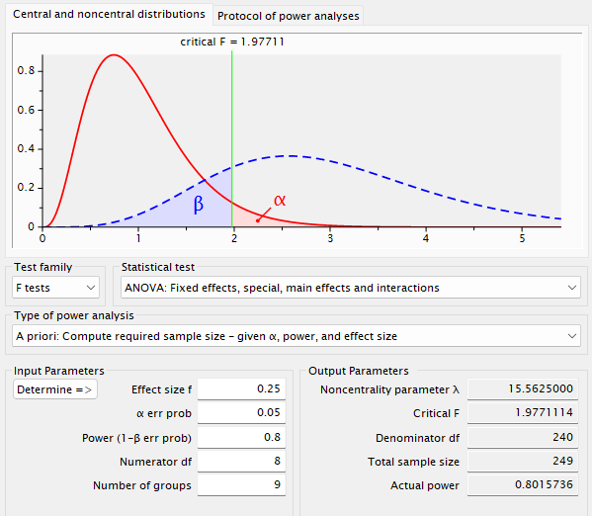

We decided to use a power of 0.8 (80%), which represents the odds of us correctly rejecting the null hypothesis when it is false. We used an alpha value of 0.05, which represents the probability of falsely rejecting the null hypothesis when it is true. We used a medium effect size of 0.25, which serves as a measure of the difference between groups. As mentioned above, we will be using a two-way ANOVA design. We will have 9 treatment groups (3 X 3). Using a numerator df of 8, our resulting sample size was 249, but we used 252 samples in order to have a balanced design with 28 individuals per group. We did make a mistake with the numerator df as it should be 4 (the degrees of freedom for our interaction term), but that led to us oversampling which should not negatively affect our results.

5. Results and Discussion

5.1 Box Plots
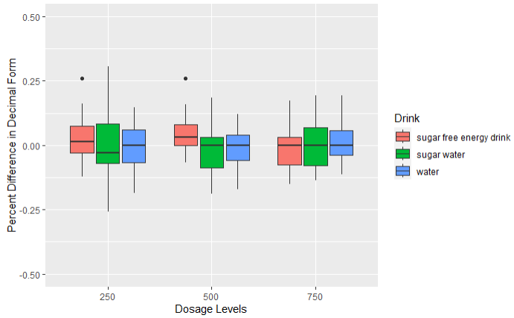
The difference between the mean for each treatment group is very small, especially when you set even a marginally large scale for reference, and it looks like within-group variability is greater than between-group variability. However, we did not expect a tremendous difference because we used percent difference as our response variable (so even a difference of ~.10 or 10% would be extremely valuable to an athlete), so it is still possible for these differences to be significant.

5.2 Interaction Plots
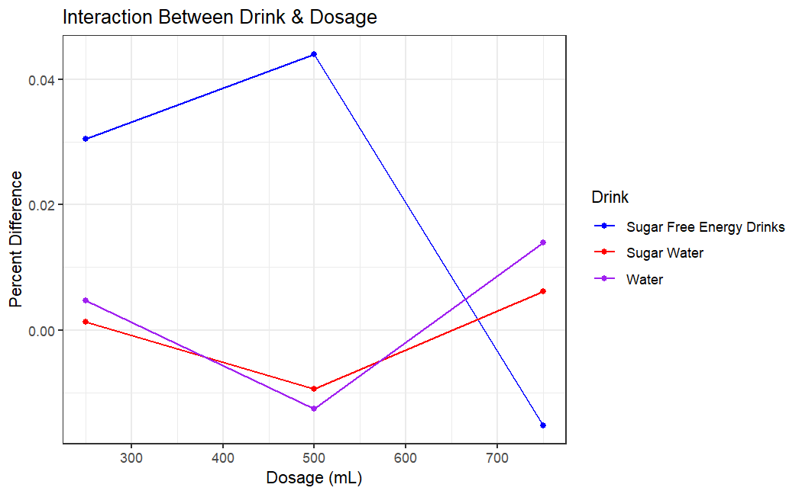
Looking at the interaction plot between the drink given to the participants and the dosage of the chosen drink, we can see that there is some level of interaction between factors. As seen in the plot above, there seems to be a positive difference between the sugar-free energy drinks and the baseline, but then decreases after taking too much. With this in mind, we expect to see the interaction between factors to be the most significant factor in our ANOVA analysis.

5.3 Anova Table
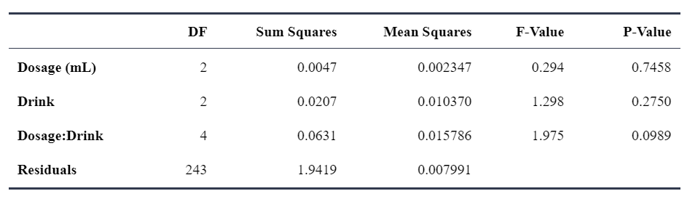
Our ANOVA analysis seems to accurately represent what we thought about the data. Both dosage and drink were not significant factors since the p-values of both factors were well above our alpha of 0.05. However, the interaction between factors seems to be the most statistically significant but still isn’t significant enough to make any conclusions. With this in mind, we are going to examine a couple of other models to see if the interaction between factors is statistically significant.

5.4 Other Models
Upon examination of the ANOVA table, it is observed that the p-value associated with the interaction between Dosage and Drink is 0.0989. This value, while not below the commonly accepted significance level of 0.05, is close enough to warrant further investigation. In pursuit of elucidating the potential underlying significant effects, we propose conducting additional ANOVA tests on alternative reduced models. These models will include: one with Dosage and the Dosage-Drink interaction, another with Drink and the Dosage-Drink interaction, and a final model with only the Dosage-Drink interaction.

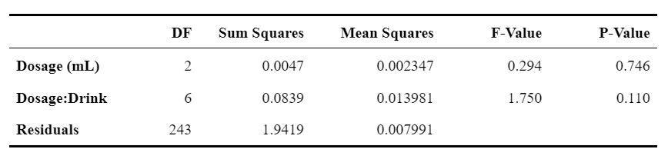

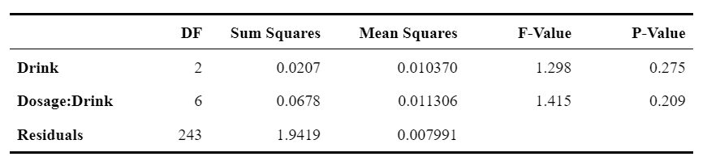

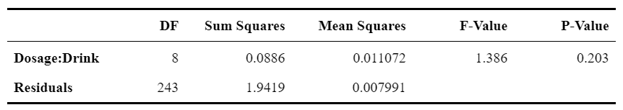

Following the analysis of the reduced models, it is observed that none of them yielded statistically significant p-values. Further investigation of reduced models does not improve the result.

5.5 Residual Diagnostics
After finding that the factors did not significantly influence exercise performance, we need to check if the model assumptions are valid to draw and confirm our final conclusions. From the residual plot, all the data points are around the zero line and randomly scattered around the plot without having obvious patterns. The variance is also constant. Then, the constant variance assumption is valid.
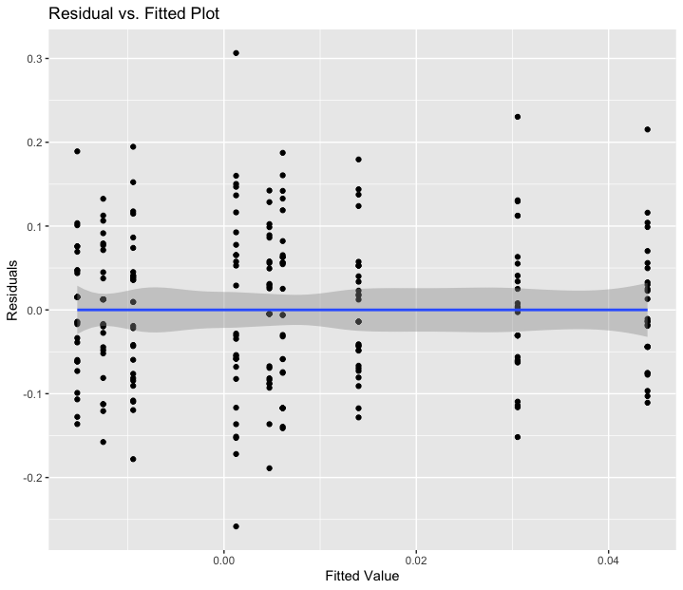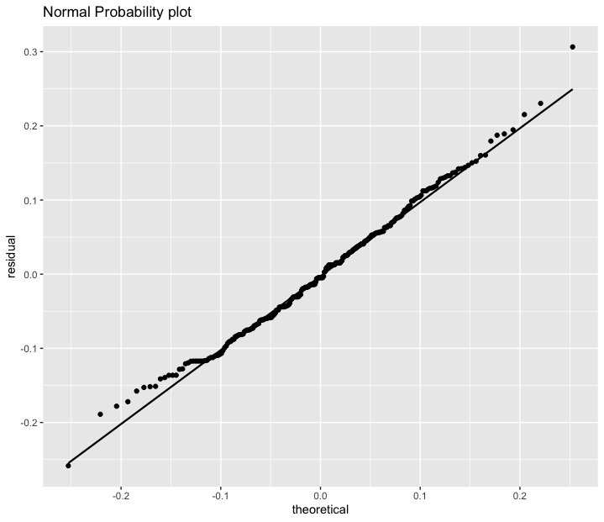

From the normal probability model, most of the data points are on the straight line, and there is only one significant outlier. Therefore, the normality assumption is valid. Thus, both the model assumptions are valid.

6. Conclusion
From the data we collected, even though we found that the sugar-free energy drink had the strongest positive effect on bicep curls from the boxplot, the ANOVA table shows that none of the types of energy drinks and dosage of energy drinks achieve significant p-values. However, out of all of the F-tests, the p-value for dosage:drink interaction was closest to significant. After further investigating the reduced models, we still cannot conclude any significant factors that influence the bicep curls performance. Moreover, since the diagnostic plot shows that the model assumptions are valid, we conclude that the type of energy drinks, the dosage of energy drinks, and the interaction between these two have no significant influence on the exercise performance.

7. Further Discussion
Overall, we were surprised that there was such little difference and that our factors were quite insignificant due to our previous research. There is some possibility The Island website just didn’t have the effect of caffeine or sugar on exercise coded properly to be reflected in the test, but one experimental explanation is that the interaction between dosage and drink type being so close to being significant caused the dosage and/or drink factor to be insignificant. Our exploration of reduced models, however, indicated that that was not really the issue.
There were some ways that the experiment could have been improved with more time and in hindsight. One way to improve the experiment would have been to test each treatment after waiting different amounts of time between the subject consuming the treatment and doing the biceps curl test (for instance, test after 15 minutes, 30 minutes, 45 minutes, etc.). Another issue might have been that we needed more isolated forms of caffeine and carbohydrates respectively to get more definite results, so it might have been better to either test caffeine or carbohydrates in pill form, if possible, or test different methods of ingesting caffeine and carbohydrates. It’s also possible that energy drinks have more profound effects on different exercises than bicep curls, such as sprinting or long-distance running; we could have done thorough research or pre-experiment testing on which single exercise would be the best to hold constant. Another thing that would’ve been interesting to test, although it isn’t possible in The Island website, would be to see if there would be a placebo effect from giving someone a flavored drink or pill and telling them it had caffeine or sugar in it when it didn’t.

8. References
- Guest, Nanci S., et al. “International Society of Sports Nutrition Position Stand: Caffeine and Exercise Performance - Journal of the International Society of Sports Nutrition.” BioMed Central, 2 Jan. 2021, jissn.biomedcentral.com/articles/10.1186/s12970-020-00383-4.
- Peinado, Ana B et al. “El azúcar y el ejercicio físico: su importancia en los deportistas” [Sugar and exercise: its importance in athletes]. Nutricion hospitalaria vol. 28 Suppl 4 (2013): 48-56. doi:10.3305/nh.2013.28.sup4.6796
- Von Duvillard, Serge P et al. “Fluids and hydration in prolonged endurance performance.” Nutrition (Burbank, Los Angeles County, Calif.) vol. 20,7-8 (2004): 651-6. doi:10.1016/j.nut.2004.04.011
- Guest, Nanci S., et al. “International Society of Sports Nutrition Position Stand: Caffeine and Exercise Performance - Journal of the International Society of Sports Nutrition.” BioMed Central, 2 Jan. 2021, jissn.biomedcentral.com/articles/10.1186/s12970-020-00383-4.
- Dillon, Pamela, et al. “Gender Differences in Any-Source Caffeine and Energy Drink Use and Associated Adverse Health Behaviors.” Journal of Caffeine and Adenosine Research, 1 Mar. 2019, www.ncbi.nlm.nih.gov/pmc/articles/PMC6444914/#:~:text=There%20are%20gender%20differences%20reported,the%20associated%20adverse%20health%20behaviors.
- Ko, Elizabeth, and Eve M. Glazier. “Caffeine Sensitivity Grows as People Age.” UCLA Health System, 1 June 2022, www.uclahealth.org/news/caffeine-sensitivity-grows-as-people-age#:~:text=Research%20shows%20that%20older%20adults,caffeine%20than%20did%20younger%20participants.
- professional, Cleveland Clinic medical. “Caffeine: How Long It Lasts, How Much & Withdrawals.” Cleveland Clinic, 23 Dec. 2020, my.clevelandclinic.org/health/articles/15496-caffeine-how-to-hack-it-and-how-to-quit-it.

